# Statement of Fact

Following the initial meeting on 30/01/2023 with the team who have committed to the Men’s Shed Group project. Joe Black had proposed that he would like to offer his services, taking the minutes of each meeting if it would be of use. Gladly, I agreed with Joe, and this will help his commitment to the running of the project by completing a management task in support of the Project Manager.

This is in addition to the commitment made for Joe to undertake the User Interface (UI) development along with Daniel Beardmore. As Joe has completed the Advanced Web Tech module, I asked him to assume the role of Principle UI Developer and share his knowledge with Daniel for the team's benefit.

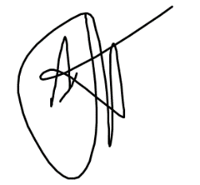

John Johnston

Project manager